

Be *Well* Informed

Onboarding Kit

E-Enterprise Portal

Updated on October 1, 2018

Table of Contents

1. Executive Summary 2

2. Frequently Asked Questions (FAQs) 3

Application 3

E-Enterprise Portal 3

Participation 3

Customization 4

Access 4

Data 4

Costs and Benefits 5

Future Improvements 5

Partners 6

Technical Details 6

3. Get Started 8

4. Understand the Process 8

5. Request, Obtain, and Verify Access to ESMT 8

6. Gather Information 10

7. Modify the partner.xml file 10

8. Modify the flowchart.xml file 13

8.1 Understand the flowchart.xml file 13

8.2 <Contaminant> 15

<Contaminant> Attributes 16

8.3 <Condition> 16

<Condition> Attributes 17

8.4 <True>, <False>, <Missing> 17

8.5 <Outcome> 17

<Outcome> Attributes 17

8.6 <Outcomes> 17

9. Test, Approve and Deploy 19

10. Appendices 23

Appendix A: Treatment Options 23

Appendix B: Treatment Order 24

# Executive Summary

The Be *Well* Informed widget and API service is a tool available within the E-Enterprise Portal (https://e-enterprise.gov) that helps private well owners evaluate their well water quality and, if advisable, water treatment options. The widget allows users to input information from private well water testing reports and provides water treatment options based on partner-specific guidance. Partners can input State, Tribe or Territory-specific contaminants of concern, treatment options, and other resources. This document identifies the path to partnership and outlines Frequently Asked Questions (FAQs) for interested parties.

The following sample and guidance files are included for reference:

* partner.xml
  + This XML file contains partner-specific information. It identifies the partner name, State/Tribe/Territory abbreviation, and pertinent support information found in the "State/Tribe Resources" area of the widget.
* flowchart.xml
  + This XML file contains the definitions of the contaminants including measured levels, their relationships to each other, and the water treatment options that would be shown to users.
* Treatment Options (as an appendix)
  + This content identifies the treatment "train", or series of water treatment options that are available within the widget. These options are static and can't be changed or configured currently.
* Treatment Order (as an appendix)
  + This content illustrates a State-developed logic model showing the different treatments that may be suggested in the tool's results. We recommend that States, Tribes and Territories develop comparable logic models to help with coding content that is specific to your State, Tribe or Territory.

# Frequently Asked Questions (FAQs)

## Application

1. **What is Be *Well* Informed?**

Be *Well* Informed is a tool designed to help private well water owners understand their water test results. If their well water has commonly found pollutants in it, the Be *Well* Informed tool provides information about health concerns and water treatment choices relevant to their State, Tribe or Territory.

1. **How was the widget developed?**

The Be *Well* Informed tool was built as part of the E-Enterprise for the Environment's (E-Enterprise) efforts to build interoperable solutions for its partners. The widget is hosted on the E-Enterprise Portal and accommodates multiple partners.

It was originally built by the New Hampshire Department of Environmental Services. They offered to share it with E-Enterprise as a demonstration of a partner-developed interoperable, reusable component on the E-Enterprise Portal. Functionality and configurability were added incrementally.

1. **Where is the widget hosted?**

The E-Enterprise Portal (https://e-enterprise.gov)[1] will host the Be *Well* Informed tool.

1. **Can I see the Be *Well* Informed widget in action?**

Yes! Simply navigate to the widget on the E-Enterprise Portal via [https://e-enterprise.gov/workbench-direct/bwi](https://e-enterprise.gov/workbench/bwi), click "Browse as Guest", and accept the Conditions of Use. This link will navigate to the widget on your workbench page.

## E-Enterprise Portal

1. **What is the E-Enterprise Portal and where can I learn more about it?**

The E-Enterprise for the Environment Portal is a new user-friendly web platform that will modernize the way the public, regulated community, and environmental co-regulators conduct environmental transactions and access web resources. The U.S. Environmental Protection Agency (EPA) is working with States, Territories, and Tribes to develop an interoperable portal, integrating data and functionality over time to create a dynamic tool for collaboration and innovation. For additional information, you may visit <https://www.epa.gov/e-enterprise>.

## Participation

1. **Who can provide information in this tool?**

E-Enterprise partners (States, Tribes and Territories and EPA) may contribute and manage their information in this tool.[2]

1. **Which States, Tribes and Territories have information in the widget?**

Currently, the following partners have data in the widget: New Hampshire, Wyoming and Massachusetts. The following partners have begun the process to onboard: Minnesota, Vermont, Michigan and Nebraska.

## Customization

1. **Can the widget be visually customized for my State, Tribe or Territory?**

The front end of the widget is not customizable for each partner. However, each partner may customize the resources provided in the "State/Tribe Resource" tab and the results page in the widget. Once an end user selects their State/Tribe/Territory and submits their test results, the pop-up results page will identify the State, Tribe or Territory in the header as well as the customized messaging. The results page is a partner product.

1. **What are the configurable elements in the tool?**

Partners can provide specific information for:

* Contaminant names, levels, and associated treatment options
* Resource materials

1. **Can I choose which contaminants I would like users to see or not see (add or remove)?**

Yes, the contaminant lists are configurable allowing States, Tribes and Territories to provide information for the most appropriate contaminants in their geography. Partners may also choose to start with a limited number of contaminants and add additional elements over time.

1. **Can I show resources for cities or counties within my State, Tribe or Territory?**

You may choose to provide resources for cities or counties on the "State/Tribal Resources" tab. We have not included the functionality for individual cities or counties to contribute specific levels and/or options. As we refined the state/tribe-level presentation in E-Enterprise Portal's version of Be *Well* Informed, the decision was made to provide State-, Tribe- or Territory-level guidance as there was no significant variation across the States who had expressed interest. This could be revisited if there is a need for greater geographic resolution across multiple partners.

## Access

1. **Can I get a copy of Be *Well* Informed for my State, Tribe or Territory's web site?**

The widget is not a downloadable program or code that runs on a State, Tribe or Territory's server. The widget is accessed through the E-Enterprise Portal and the user selects the State, Tribe or Territory for which they want to see results.

1. **How can States, Tribes and Territories direct users to the widget?**

Partners should use the direct link to the widget on the E-Enterprise Portal on their website. This is <https://e-enterprise.gov/workbench-direct/bwi>. As initial adopters create these linkages, we can share their experiences with usability and their text.

## Data

1. **Does the widget collect data?**

No, the application is set up as a 'calculator' function. The user enters data and results are provided. No data is saved.

1. **What metrics are collected for the Be *Well* Informed widget?**

We have a "use" metric for the Be *Well* Informed that allows us to capture usage at the State, Tribe or Territory level. This will enable participating partners to capture their benefit more directly.

## Costs and Benefits

1. **Is there a cost to participate?**

At this time, as a demonstration project, there is no cost to States, Tribes or Territories to participate. Our hope is to demonstrate the utility of this Enterprise approach and to seek ways to create solutions that benefit multiple partners at overall lower costs and to distribute the burden for operations and maintenance. New Hampshire hopes that this "pay it forward" philosophy with shared services will motivate other entities to follow suit and be willing to share tools that they develop so that ultimately all partners benefit.

1. **Could there be a charge in the future?**

Any decision to change the approach will be discussed with the participating partners as far in advance as possible.

1. **What is the level of effort to configure the widget?**

Based on our experience with the States, we expect it will take approximately TBD[3] hours for a person experienced with XML or TBD for a non-technical person to code the XML files. As a new partner you will be able to use the XML code from an existing partner as a template. Therefore, you will only need to edit that content that is specific to your State, Tribe or Territory. We encourage participating partners to share information on level of effort so this may be updated over time.

1. **What are the expected benefits to States, Tribes and Territories to adopt this widget?**

New Hampshire reports that there has been a significant reduction in the number of hours that staff dedicated to answering questions resulting from private well water testing. They still respond to more complex questions but are able to realign the staffing to higher functions.

Massachusetts reports that the coding for the initial set of contaminants took only seven hours to complete[4]. The time to compile the information and gain agency approvals were more time-consuming. This was not a project that would have received development resources without this tool.

We also encourage participating partners to share feedback about benefits from the tool.

1. **What is the expected return on investment (ROI) for implementing the widget?**

TBD[5]

## Future Improvements

1. **Are any improvements planned for the widget?**

With the exception of two items which are in development, no additional functions are planned at this time. These two items are: a direct link to launch the widget and the use metric.

1. **I have an idea on how to improve this widget or how to reuse it in another context. Who do I contact?**

We are always looking for ways to build enterprise approaches that meet multiple partners' needs. You may send an email to the E-Enterprise Portal Coordinator at eportal [at] epa.gov and include "Be Well Informed" in the subject line.

## Partners

1. **What is expected of partners?**

A partner should expect to:

* Compile the necessary information for contaminant names, levels, treatment options, and associated resource materials.
* Provide a point of contact for the CDX Helpdesk to direct inquiries to. This will be, by default, the phone and email address provided in the Phone Support section of the code.
* Gain appropriate approvals within your organization for posting the materials in this public-facing widget.
* Modify the associated XML files, as needed.
* Agree to maintain the information over time.
* Track metrics for user inquiries to partner.
* Provide usability feedback for the widget and materials.
* Contribute to the governance of the widget, as needed.

EPA expects to:

* Host and maintain Be *Well* Informed.
* Provide Helpdesk support for the function of the widget and track metrics for user inquiries. Content questions will be redirected to partners.
* Provide demonstrations of its use.
* Provide onboarding tools for States, Tribes and Territories to participate.
* Coordinate public communications with participating partners.

1. **Where can I find the Helpdesk materials?**

The future version of this document will include a link to the guidance provided to the CDX Helpdesk.

1. **Who may I contact if I have questions?**

Send an email to the E-Enterprise Portal Coordinator at eportal [at] epa.gov and include “Be Well Informed” in the subject line.

1. **I have decided to partner. How do I begin to add my State, Tribe and Territory's information to Be *Well* Informed?**

Go ahead and dive into the next sections of this kit. The "Understand the Process" section has a list of general steps you will need to follow.

## Technical Details

1. **Do I have to be technically-inclined to become a partner?**

No! Several of the partners are using non-technical people to code their State's information into the XML file. The "Get Started" section has additional information and guidance.

1. **What is an XML file?**

XML stands for eXtensible Markup Language. XML is designed to store and transport data and to be both human- and machine-readable.

1. **How can I edit an XML file?**

There are a number of ways to edit XML files, but the most common are simple text editors. We recommend that you refer to "Get Started" section for a list of suggested text editors.

1. **Where do I find the configuration files?**

The XML files and other documentation used for Be *Well* Informed may be found contained in this document and typically included as attachments during delivery.

1. **Where do I find the details about service requirements?**

# Service Level Commitments for the E-Enterprise Portal and related services, such as BWI, are currently in development. Availability will be based on CDX services and other dependencies. SLCs will be included here in the future. Get Started

This onboarding kit offers a comprehensive guide to setting up the Be *Well* Informed widget for your State, Tribe or Territory. Please read through this guidance in its entirety before you begin.

Edits to one or more text files are necessary to support the onboarding process. While any text editor will work to edit XML (eXtensible Markup Language), it is highly recommended you use a program with syntax highlighting, code completion, and XML validation. An example program is XML Notepad, an open source editor from Microsoft, which may be downloaded from <https://github.com/Microsoft/XmlNotepad/wiki>. If you're unfamiliar with XML, we suggest you review the guidance provided by <https://www.w3schools.com/xml/>.

# Understand the Process

Generally, the steps to adopt this tool are as follows. These steps are covered in more granular detail in the sections that follow (5, 6, etc.).

1. Create a Shared CROMERR[6] Services (SCS) account in Exchange Network Central Data Exchange (CDX) to gain access to the provisioning tool, Enterprise Services Management Tool (ESMT), so you can download current onboarding materials and upload, test and deploy your code.
2. Gather information needed for the two XML files.
3. Use <https://e-enterprise.gov/workbench-direct/bwi> to create a link from partner's site to E-Enterprise Portal production site.
4. Modify the partner.xml file and flowchart.xml file to reflect partner-specific information.
5. Test.
6. Prepare instructions for the end user to access and use the service.
7. Identify where to place end user instructions (e.g., partner's Drinking Water page).
8. Gain your agency's approval to "go live" and post the information.
9. Deploy.

# Request, Obtain, and Verify Access to ESMT

Interested partners should follow these steps:

1. To notify us of your intent to partner, please contact the E-Enterprise Portal Coordinator: eportal [at] epa.gov.
2. EPA will assess if there are adequate resources available to support the partner's adoption or if other considerations apply.
3. Email SCS Help Desk at sharedcromerrservices [at] epacdx.net. The email needs to include:
   1. Your name and affiliation (State, Tribe or Territory).
   2. A statement that you need to register to get ESMT rights in the E-Enterprise Portal and want to participate in the Be *Well* Informed tool.

The SCS Help Desk will forward this information via email request to EPA. Once EPA reviews and gives the green light for the requesting partner to proceed with provisioning as an ESMT/Be *Well* Informed Partner, SCS Help Desk coordinates the Tier III provisioning. You will receive an email from the SCS Help Desk when the account is set up. After receiving a reply from the SCS Help Desk with your account information, please follow the steps outlined below for either Option 1 or Option 2 to verify your access to the ESMT and download templates/instructions.

Option 1

1. Navigate to the E-Enterprise Portal via https://test.e-enterprise.gov.
2. Click "Login".
3. Select "CDX/Exchange Network".
4. Input the credentials you were provided and click "Sign in".
5. Then, from the E-Enterprise Portal Workbench, click the "Shared Services" hyperlink near the top of the page as shown below:

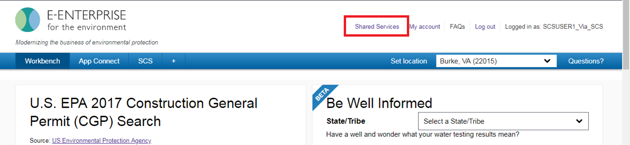

1. Then, from the E-Enterprise Partner Area, you may click the "Partner Kit" for any of the existing Be *Well* Informed partners to download templates/instructions and begin modifying the appropriate XML files as shown below:

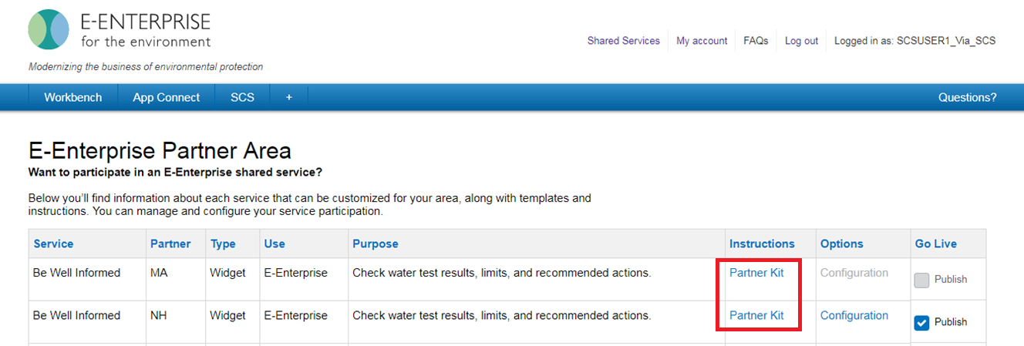

Option 2

1. Navigate to the Shared CROMERR Services Dashboard via https://encromerrtest.epacdxnode.net.
2. Input the credentials you were provided and click "Log In".
3. From the Shared CROMERR Services Dashboard, click the "Go to E-Enterprise" link as shown below:

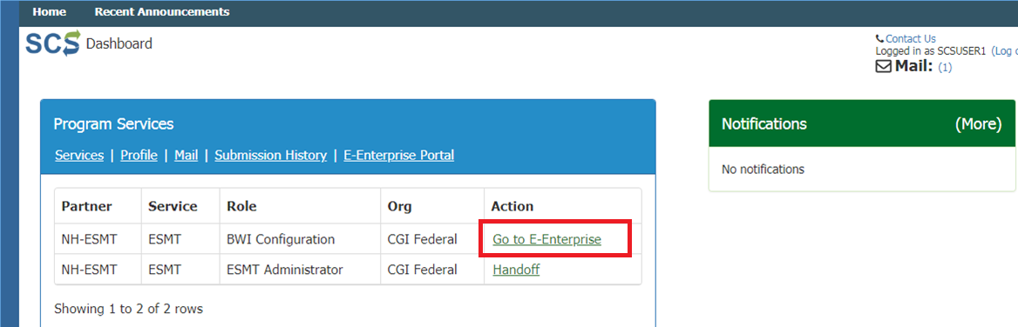

1. Then, from the E-Enterprise Portal Workbench, click the "Shared Services" hyperlink near the top of the page as shown below:



1. Then, from the E-Enterprise Partner Area, you may click the "Partner Kit" hyperlink for any of the existing Be *Well* Informed partners to download templates/instructions and begin modifying the appropriate XML files as shown below:



# Gather Information

The information required for Be *Well* Informed is in two key areas: 1) the partner's support and resource information, and 2) the partner's water quality standards and customized messaging. These elements are organized into two separate XML files. You will need to:

1. Provide the partner's specific information in the corresponding XML file (partner.xml). It contains the partner's identity, contact information, and additional resources.
2. Apply the partner's water quality standards and customizations to the analysis, interpretation, and recommended user action messages shown to the users for water treatment options (flowchart.xml).

The new partner will start with an existing flowchart.xml from an existing partner for use as a template. We recommend you identify the existing partner's logic that most closely matches your needs to minimize the changes required to make it consistent with regulations and/or guidelines for private wells in your geography.

# Modify the partner.xml file

The focus of this first step is to establish the partner's specific information. The steps below will take you through the process to modify the XML contained in the file. Please note the State of New Hampshire will be referenced for guidance purposes in this section.

1. partner.xml is composed of 4 parts: <Name>, <Code>, <SupportInformation>, and <Results>. The node, "SupportInformation", is abbreviated in the sample before for brevity and contains additional content that will be discussed.

Code Block 1 partner.xml

|  |
| --- |
| <Partner>  <Name></Name>  <Code></Code>  <SupportInformation>...</SupportInformation>  <Results>...</Results> </Partner> |

Insert the appropriate information in the first two nodes.

Code Block 2 partner.xml

|  |
| --- |
| ... <Name>Sample Partner Name</Name> <Code>SAMPLE</Code> ... |

This information controls an additional information tab.

IMPORTANT: Please note that the CDX Helpdesk[7] will direct end users who have questions about the content of their results to the point of contact provided in the first section (Phone Support) below.

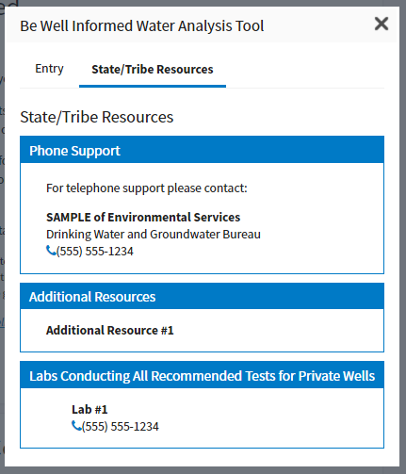

1. The <SupportInformation> contains <Section>. Each of these creates the sections shown in the screenshot above.  
     
   The <Section> supports HTML content but requires it to be wrapped in <![CDATA[]]>. Below are three custom sections inside the <SupportInformation>. The additional sections are abbreviated by ellipses.

Code Block 3 partner.xml

|  |
| --- |
| ... <SupportInformation>  <Section html="true">  <![CDATA[<h4>Phone Support</h4>  <p class="bwi-support-intro">For telephone support please contact the Sample Department of Environmental Service's Drinking Water and Groundwater Bureau:</p>  <ul class="plain-list bwi-resources-list">  <li>  <p class="bwi-resource-name">Sample Department of Environmental Services</p>  <p>Drinking Water and Groundwater Bureau</p>  <p>1234 Cook St</p>  <p>New City, StateCode 00000-0000</p>  <p><i class="fa fa-phone"></i>(555) 555-1234</p>  <p><i class="fa fa-send"></i>info@sdes.sample.gov</p>  </li>  </ul>]]>  </Section>  <Section html="true">  <![CDATA[<h4>Additional Resources</h4>...]]>  </Section>  <Section html="true">  <![CDATA[<h4>Labs Conducting All SDES Recommended Tests for Private Wells</h4>...]]>  </Section> </SupportInformation> ... |

1. Below is a deeper view of the HTML inside the CDATA tag.

Code Block 4 partner.xml

|  |
| --- |
| ... <h4>Phone Support</h4> <p class="bwi-support-intro">For telephone support please contact the Sample Department of Environmental Services' Drinking Water and Groundwater Bureau:</p> <ul class="plain-list bwi-resources-list"> <li> <p class="bwi-resource-name">Sample Department of Environmental Services</p> <p>Drinking Water and Groundwater Bureau</p> <p>1234 Cook St</p> <p>New City, StateCode 00000-0000</p> <p><i class="fa fa-phone"></i>(555) 555-1234</p> <p><i class="fa fa-send"></i>info@sdes.sample.gov</p> </li> </ul> ... |

|  |
| --- |
| **Tip**  When editing HTML that is part of the CDATA tag, separate the content into a separate file. Most editors don't provide syntax highlighting for content inside the CDATA tags. When edits are complete, copy and paste the changes back into the XML file. |

Each section requires a <h4> header and it must contain a title. This is the only requirement for each section.

1. The <Results> node is used to help customize sections of the returned results from the Be *Well* Informed service. There are several customizable texts that appear in the node:
   * **Heading** - Identifies the partner.
   * **Introduction** - Provides the opening text to the response.
   * **AboutTheResults** - Provides a pretext to the results display.
   * **WaterTreatmentSystems** - Provides text that accompanies the water treatment system information.
   * **Key** - Provides a results key that allows for customization of the result labels.

# 

# Modify the flowchart.xml file

The focus of this step is to establish the partner's response to the user-entered water pollutant contaminant levels. The steps below will take you through the process to modify the XML. It is recommended that you review the sections below before proceeding to modify the flowchart XML file. As a new partner you will use the XML code from an existing partner such as New Hampshire and modify it to meet your requirements. Therefore, the new partner only needs to make changes to partner-specific outreach material and where contaminant concentrations, interpretation, and/or action messaging needs to be revised to be consistent with the new partner's regulations and/or guidelines for private wells.

## 8.1 Understand the flowchart.xml file

flowchart.xml is used to describe the behavior of the Be *Well* Informed service. The root node <FlowCharts> is composed of several sub-sections: <Sections>, <Conversions>, and <Contaminants>.

Code Block 5 flowchart.xml

|  |
| --- |
| <FlowCharts>  <Sections>...</Sections>  <Conversions>...</Conversions>  <Contaminants>...</Contaminants> </Flowcharts> |

The first part <Sections> is used to describe the structure and organization of the Contaminants in the widget.

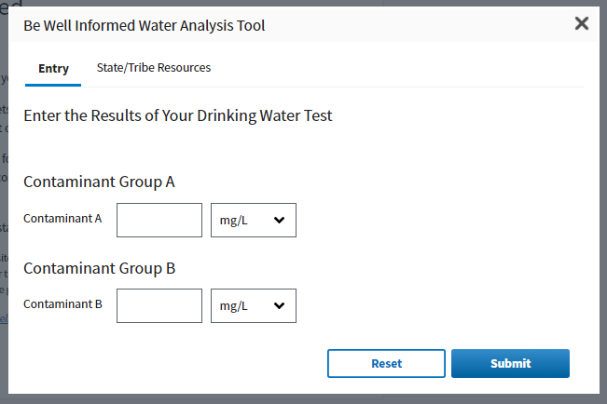

Above you can see the two groups (sections) of contaminants: "Contaminant Group A" and "Contaminant Group B". Each of these is defined in <Sections>. Each child node represents one of these groups and uses a unique tag name (i.e., <ContaminantGroupA>). This is the machine name used by the Be *Well* Informed service. This will be important when defining a contaminant. Inside each of these is a single node <Name> which contains the human-readable name used in the Be *Well* Informed widget.

The next subsection is <Conversions> and is used to define how to change from one unit to another. A default set of definitions is provided to you as a starting point. In most cases, this section will not need modification.

These conversions are multiplicative in nature. The base unit is selected and the unit that is being converted 'To' is multiplied by the given value (attribute) to find the new value.

Code Block 6 flowchart.xml

|  |
| --- |
| <Conversions>  ...  <Conversion name="mg/L">  <To name="g/L" value="0.001" />  <To name="µg/L" value="1000" />  <To name="gpg" for="Ca" value="0.0584178313186289" />  <To name="ppm" for="" value="1.0017961204" />  <To name="ppb" for="" value="1001.7961204" />  </Conversion> ... </Conversions> |

For example, if the default unit of the contaminant is based on µg/L and the user gives a value in mg/L, the service will look up the <Conversion> with *name* equal to "mg/L" and retrieve the *value* of the <To> with the *name* equal to "µg/L". This value is multiplied by the user-provided value. The service assumes that if the conversion is not listed, it shall not be converted and the value is left intact. In the case that a specific conversion value is needed for a particular contaminant, use the *for* attribute to identify the contaminant for which the conversion will be used. For example, in the snippet above, the text shows *<To name="gpg" for="Ca" value="0.0584178313186289" />.* The conversion for gpg may be different depending on the contaminant in question. This conversion is only for *Ca*.

<Contaminants> can contain any number of <Contaminant>. These contaminants are the principal elements of the XML. In the example, below most of the file has been abbreviated to help highlight the individual components, attributes, and the relationships to each other.

Code Block 7 flowchart.xml

|  |
| --- |
| <Contaminants>    ...   <Contaminant Section="ContaminantGroupA" Value="ConA" Text="Contaminant A" DefaultUnit="mg/L" Units="g/L|mg/L|µg/L" MCL="-" NotEntered="Test your water. Studies show that many private wells have Contaminant A.">  <Condition CheckOperator="=" CheckValue="0">  <True>  <Outcome GuidelineIcon="M" GuidelineText="There is no drinking water guideline or standard" />  </True>  <False>  <Condition CheckOperator="&gt;=" CheckValue="150.0">  <True>  ...  </True>  <False>  ...  </False>  </Condition>  </False>  <Missing>  <Outcome IM="ConA1" HM="ConA1" TM="ConA1" TreatmentOrder="1b" GuidelineIcon="E" GuidelineText="There is no drinking water guideline or standard" />  </Missing>  </Condition>   <Outcomes>  <InterpretationMessages>  <ConA1>...</ConA1>  </InterpretationMessages>   <HealthMessages>  <ConA1>...</ConA1>  </HealthMessages>   <TreatmentMessages>  <ConA1>...</ConA1>  </TreatmentMessages>  </Outcomes>  </Contaminant>   </Contaminants> |

## 8.2 <Contaminant>

These nodes are located as children of the <Contaminants>. An individual node is composed of three notable parts: attributes, the initial condition node, and the possible outcomes node.

Each part is used to dictate how to present the contaminant to the user and how it will be processed in the Be *Well* Informed service.

The guidance below reviews the various attributes. Each contaminant requires a number of attributes along with several that need to be set.

### <Contaminant> Attributes

These can be divided into two groups:

Service-based:

* **Value** - The contaminant abbreviation. This is a unique identifier used by the system to recognize contaminants. This value is used as the prefix to the outcome messages.
* **MCL** - Maximum Contaminant Level. This controls the maximum value and unit used by the system.

UI based:

* **Text** - The contaminant full descriptive name that is displayed in the widget.
* **NotEntered** - Default message is given when no value is submitted by the user. This text is seen in the result returned by the service.
* **Section** - Reference to <Sections> child node to which this contaminant is associated. See the previous explanation of <Sections> for more information.
* **Units** - This is a list of different units that are available to the user in the drop-down next to the contaminant in the widget. When listing several units, separate the labels with a pipe character | and without extra space around the label itself. An example is "MPN/100 mL|CFU/100 mL". While the label contains an internal space the surrounding label is trimmed and separated by the pipe character |.
* **DefaultUnit** - This is used to select the default unit from the list of units found in the Units attribute mentioned above.
* **ShowIsPresent** (optional) - This value is used to show the Present and Absent radio button for the given contaminant.

This node has two children nodes: <Condition>, <Outcomes>.

|  |
| --- |
| **Caution**  Be careful when editing the *Value* attribute of the <Contaminant>. Its value is used to compute more than the label shown in the widget. This is used to create the prefix for the *IM, HM, TM* attributes of the <Outcome> and create the response nodes. More information about the importance of this can be found in Section 5.6. |

## 8.3 <Condition>

This node represents the logic for every decision. It is composed of three essential parts. The first of these is the actual condition statement, the <True> (pass action), and the <False> (fail action). Optionally, there is a <Missing> tag that is available in the scenario where a value is not input by the user.

### <Condition> Attributes

* **CheckOperator** - This is the truth operation. Accepted values are >, <, =, >=, <=
* **CheckValue** - This is the value to be compared using the CheckOperator

When editing these values, it should be read as "if the user's value is [CheckOperator] than/to [CheckValue]". For example, <Condition CheckOperator=">=" CheckValue="30"> should be read "if the user's value is greater than or equal to 30". Based on the result of that condition the logic will move to follow the action given in resulting truth value.

This node has two children nodes: <True>, <False>

## 8.4 <True>, <False>, <Missing>

The content of these nodes expect one of three nodes to be used, <Outcome>, <Prompt> or another nested <Condition>, which allows for near endless additional condition to be added to the logic by nesting them inside of each other. An example of this is the <Condition> logic for Arsenic provided in the sample XML.

The <Prompt> node works the same as <Condition> except that it is an attempt to get additional information from the user. This sends a question(s) back to the UI from the service asking a true/false question to the user.

## 8.5 <Outcome>

These nodes use the information inside its attributes to link to the response messages <Outcomes>. These links allow the same response to be used for different results. It's advisable to review the attributes to understand how to edit the linked response.

NOTE: This is different from <Outcomes> and is only used as a child node of truth value.

### <Outcome> Attributes

* **IM** - This connects to the node of the same name in the <InterpretationMessages>. This will return the interpretation message in the content section of the associated node as part of the result for this contaminant. For example, a value of "ConA1" links to <ConA1>.
* **HM** - This connects to the node of the same name in the <HealthMessages>. This will return the health message in the content section of the associated node as part of the result for this contaminant. For example, a value of "ConA1" links to <ConA1>.
* **TM** -This connects to the node of the same name in the <TreatmentMessages>. This will return the treatment message in the content section of the associated node as part of the result for this contaminant. For example, a value of "ConA1" links to <ConA1>.
* **TreatmentOrder** - The code corresponds to treatment options available in the treatment chart. Review the TreatmentOrder.pdf file for additional information.
* **GuidelineIcon** - This relates to the available icons. Accepted values are M (meets), W (warning), E (exceeds).
* **GuidelineText** - This text is configurable and explains how the user's value relates to the guideline.

## 8.6 <Outcomes>

This section is composed of three outcome types <InterpretationMessages>, <HealthMessages>, and <TreatmentMessages>. The structures of these are the same. Each response node follows the pattern of using the contaminant *Value* (found in <Contaminant>) combined with an integer. In the case of "Contaminant A" we see <ConA1>, <ConA2>, etc. These are unique to the outcome type, but not necessarily unique inside of the <Outcomes>. For each unique response message needed, add another node using the contaminant value prefix and increment the integer as needed. Below are several examples. The response node contains a single child node, <Content>, which is used to hold a HTML message.

Code Block 8 flowchart.xml

|  |
| --- |
| ... <Outcomes>  <InterpretationMessages>  <ConA1>  <Content>  <b>Lorem ipsum</b> dolor sit amet, vix essent intellegat an, diam recusabo ei quo, eos ancillae theophrastus ei. Usu summo placerat et. Pri illum malorum disputationi at, mei ad doming iracundia. Meliore facilisis id nec, facer iudico ei nam, civibus accusata vis in.  </Content>  </ConA1>  <ConA2>  <Content>  </Content>  </ConA2>  <ConA3>  <Content>  <b>Vim malis</b> quidam maluisset no, ne tollit ancillae cum, te nec euismod inciderint. Vim ne malis petentium, everti scaevola usu ad. Errem offendit probatus et qui, eu nec legendos quaestio, te mea wisi nonumy. At aeterno scripserit vim, id posse inani civibus qui.  </Content>  </ConA3>  </InterpretationMessages>   <HealthMessages>  <ConA1>  <Content>  <b>Usu summo placerat et.</b> Pri illum malorum disputationi at, mei ad doming iracundia. Meliore facilisis id nec, facer iudico ei nam, civibus accusata vis in. Lorem ipsum dolor sit amet, vix essent intellegat an, diam recusabo ei quo, eos ancillae theophrastus ei. <br/>  <br/>  Vim ne malis petentium, everti scaevola usu ad. Errem offendit probatus et qui, eu nec legendos quaestio, te mea wisi nonumy. At aeterno scripserit vim, id posse inani civibus qui.  </Content>  </ConA1>  <ConA2>  <Content>  </Content>  </ConA2>  <ConA3>  <Content>  <b>Usu summo placerat et.</b> Pri illum malorum disputationi at, mei ad doming iracundia. Meliore facilisis id nec, facer iudico ei nam, civibus accusata vis in. Lorem ipsum dolor sit amet, vix essent intellegat an, diam recusabo ei quo, eos ancillae theophrastus ei. <br/>  <br/>  Vim ne malis petentium, everti scaevola usu ad. Errem offendit probatus et qui, eu nec legendos quaestio, te mea wisi nonumy. At aeterno scripserit vim, id posse inani civibus qui.  </Content>  </ConA3>  </HealthMessages>   <TreatmentMessages>  <ConA1>  <Content>  <b>Pri illum malorum disputationi at</b>, mei ad doming iracundia. Meliore facilisis id nec, facer iudico ei nam, civibus accusata vis in. Lorem ipsum dolor sit amet, vix essent intellegat an, diam recusabo ei quo<a target="_blank" href="http://example.com">Fact Sheet</a>.<br/>  </Content>  </ConA1>  <ConA2>  <Content>  </Content>  </ConA2>  <ConA3>  <Content>  </Content>  </ConA3>  </TreatmentMessages> </Outcomes> ... |

# Test, Approve and Deploy

To upload and test your XML files, access the E-Enterprise Partner Area:

1. Navigate to the E-Enterprise Portal via https://test.e-enterprise.gov.
2. Click "Login".
3. Select "CDX/Exchange Network".
4. Input the credentials you were provided and click "Sign in".
5. Then, from the E-Enterprise Portal Workbench, click the "Shared Services" hyperlink near the top of the page as shown below:



1. Then, from the E-Enterprise Partner Area, you may click the "Configuration" hyperlink as shown below:

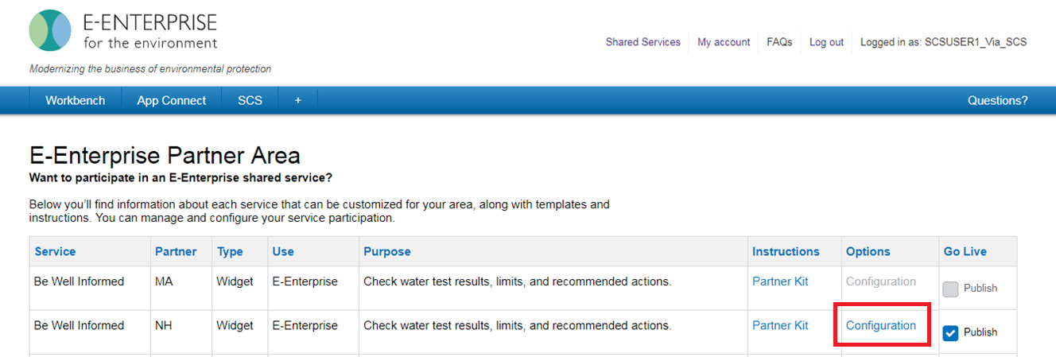

1. Next, upload the partner and flowchart XML files using the file upload functionality as shown below:

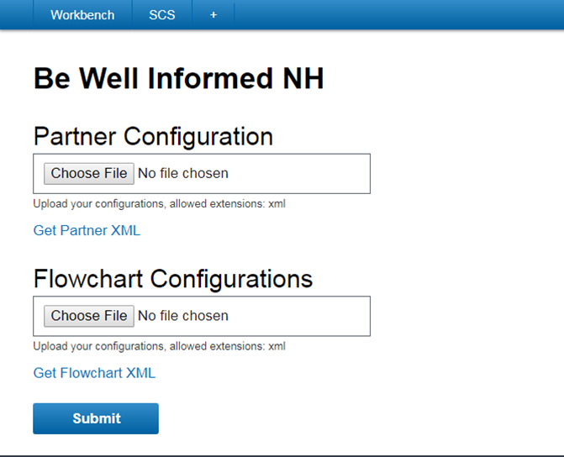

1. Click "Submit".
2. Both XML files will be validated for well-formed syntax. If any errors are detected, a validation message will be shown.
3. After the upload is completed successfully, a notification will be displayed as shown below:

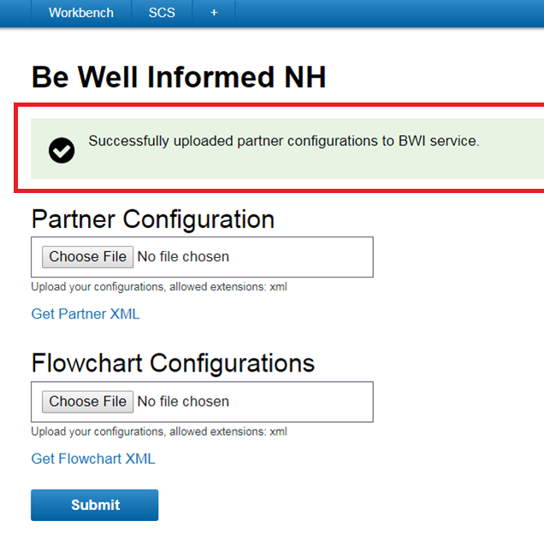

1. After successfully uploading the XML files, use your browser's back button to return to the E-Enterprise Partner Area.
2. Then, click the "Publish" element as shown below:

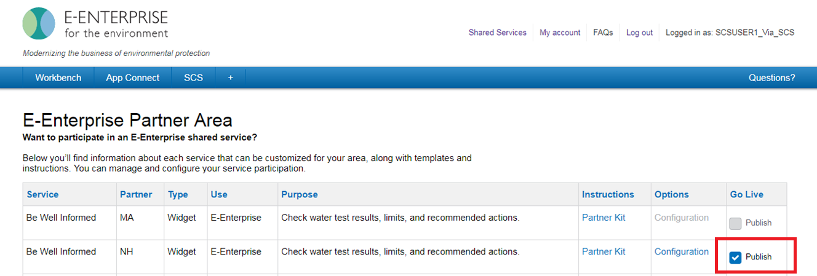

1. At this time, you may return to the E-Enterprise Portal Workbench, select your "State/Tribe" from the dropdown menu in the "Be *Well* Informed" widget, and click "Check your water" as shown below:

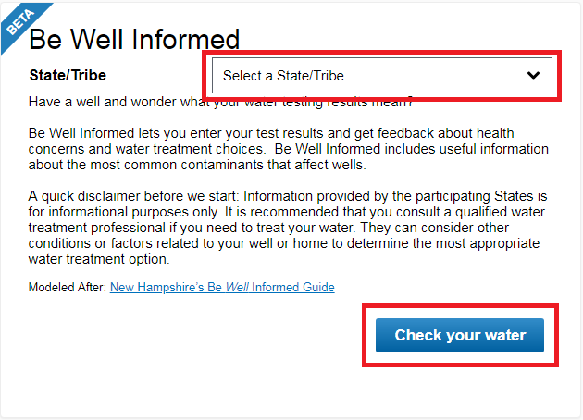

1. Ensure the information displayed is accurate and the tool functions correctly.
2. Use the tool and make sure it functions as expected. Does the logic provide the responses you expected for each of your elements? Do all of your resources show appropriately in the State/Tribe Resources tab? Is the user experience consistent in most Web browsers? Does the PDF generation work and format as you would expect? For your convenience, a checklist template will be provided in the future.
   1. You're encouraged to execute tests against all contaminants identified in your XML file and verify that the results are as expected across multiple Web browsers, including Microsoft Internet Explorer, Microsoft Edge, Mozilla Firefox, Google Chrome, Safari, and the native mobile iOS and Android browsers.
   2. You're also encouraged to verify that any multiple contaminant logic is working as expected.
   3. Lastly, ensure that all of the dropdown menus identifying the units of measure display as expected.
3. Provide agency approval to E-Enterprise Portal Coordinator, eportal [at] epa.gov. A sample memo will be provided in the future.
4. Once satisfied and you have your agency's approval to post, you can then "go live." To "go live," perform these same steps in the Production environment using the following URLs:
   1. E-Enterprise Portal: <https://e-enterprise.gov/workbench-direct/bwi>
   2. Shared CROMERR Services: https://encromerr.epa.gov

.

# Appendices

## Appendix A: Treatment Options

Multi-Contaminant Treatment Sequence Flow Chart (2/4/2015)

Order for a treatment train may be applied for treatments recommended by logic models. The sequence for a treatment train can be determined based on the order 1 (first) – 5 (last) treatment.

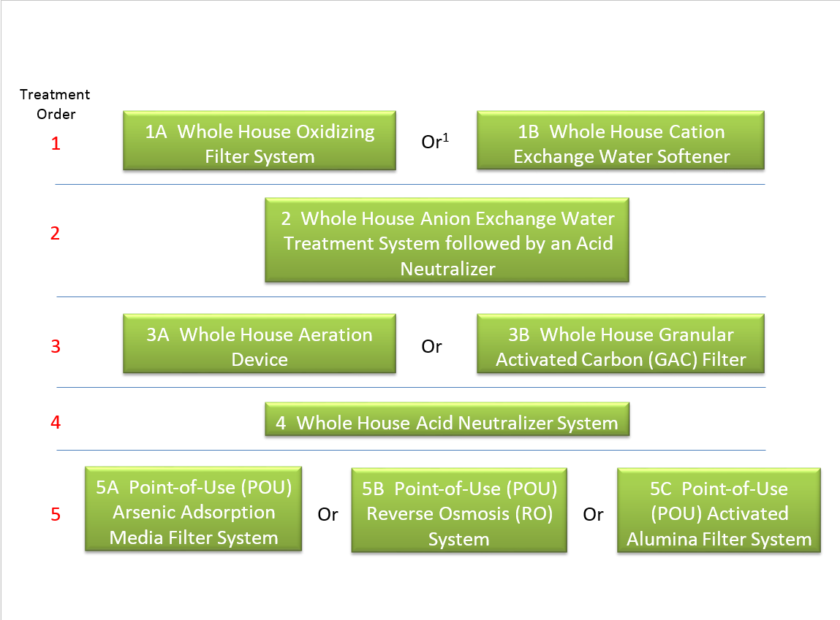

1"Or" indicates there are two or three possible treatment options in the same order; "A" being first, "B" being second in terms of sequence in those cases.

## Appendix B: Treatment Order

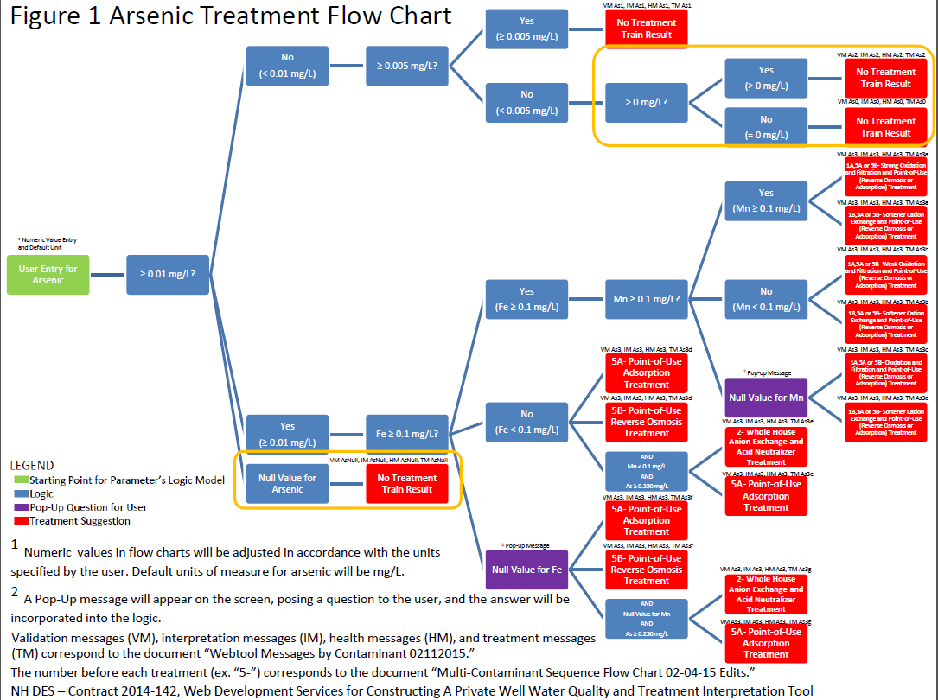

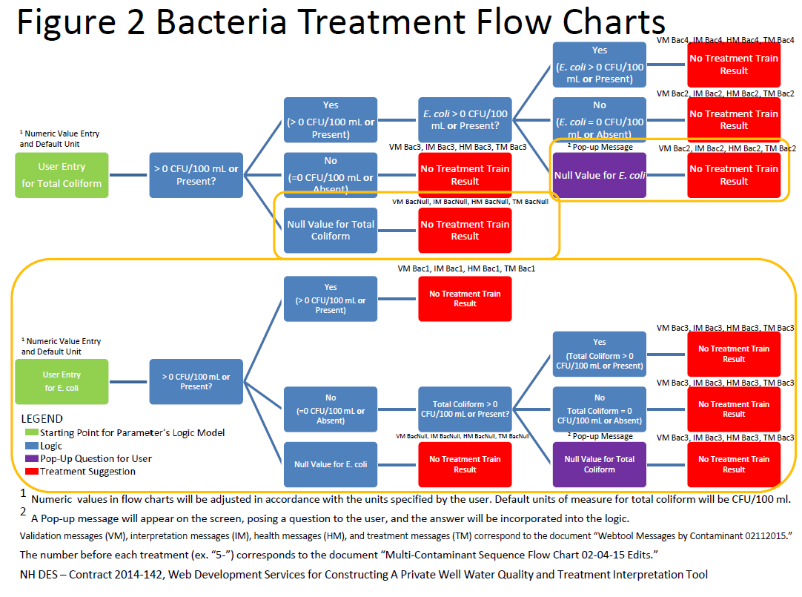

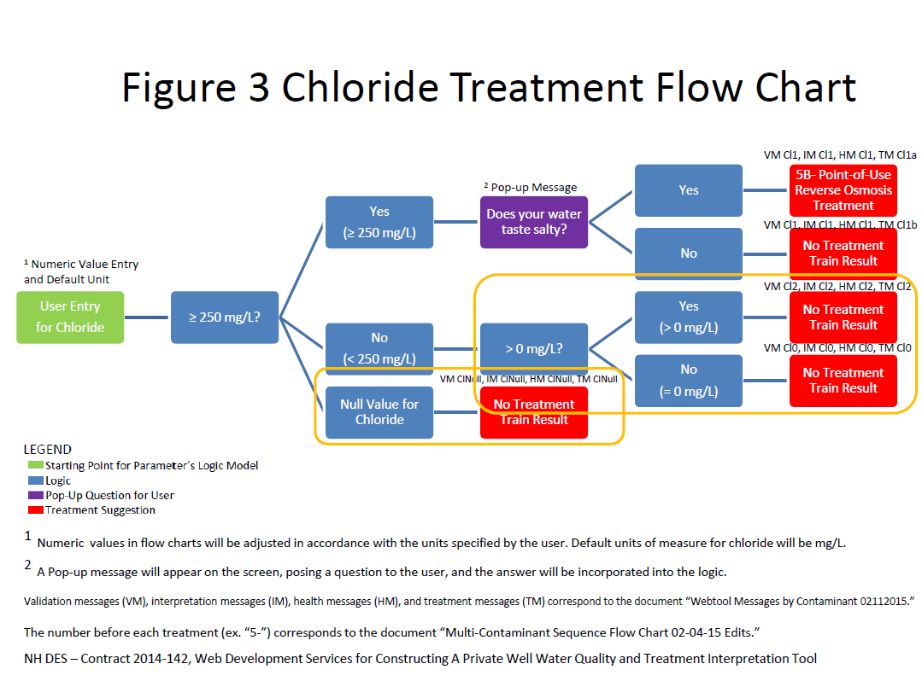

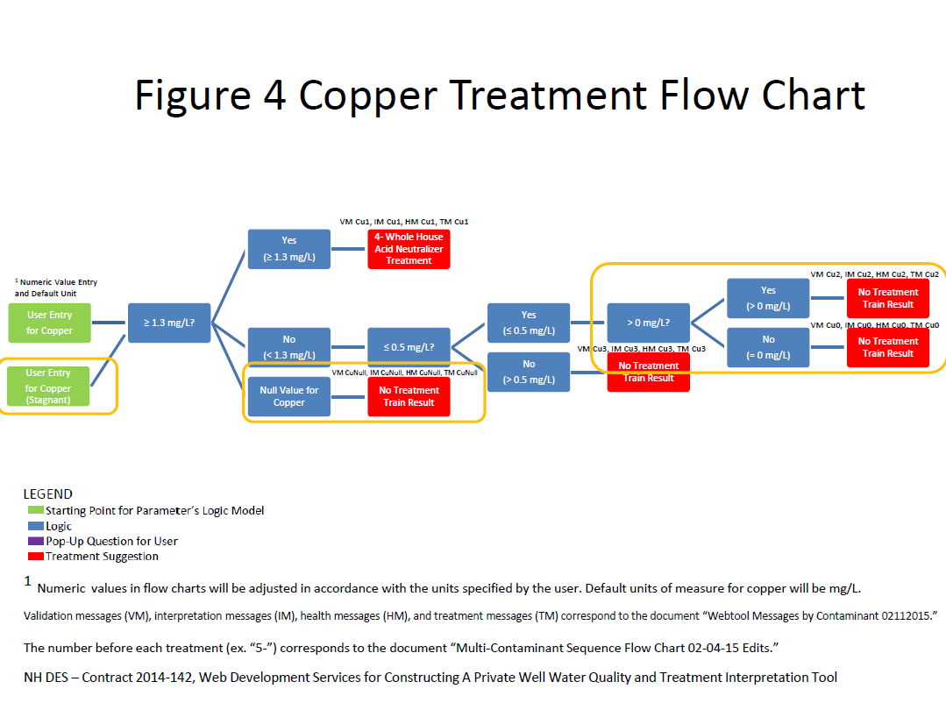

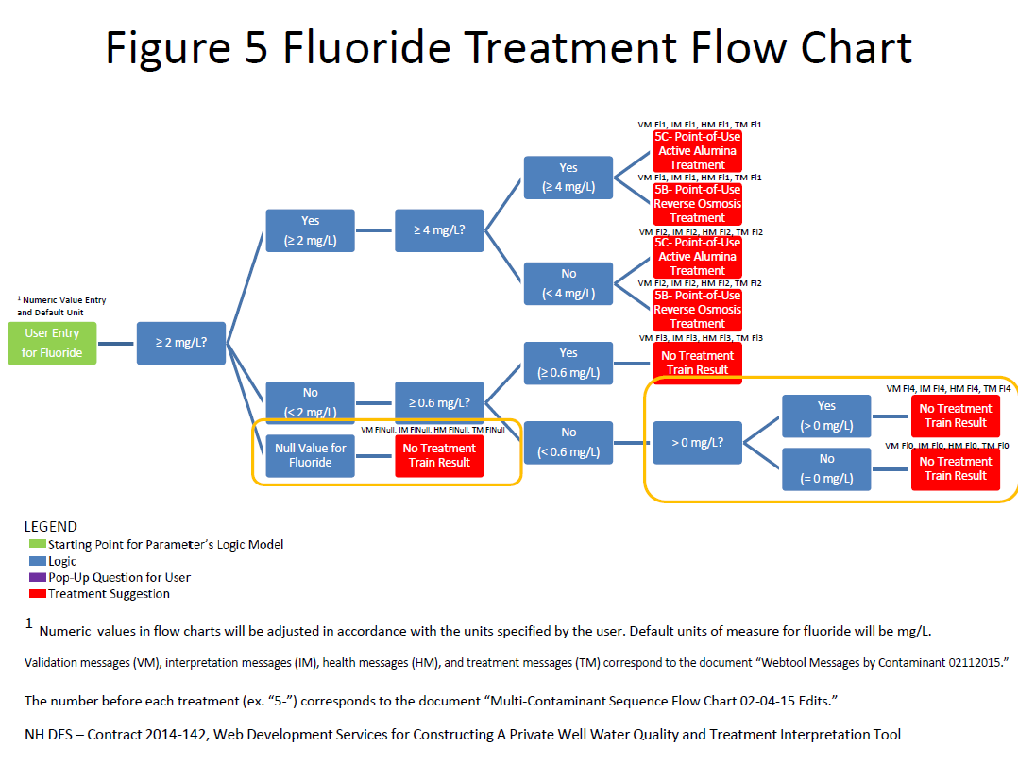

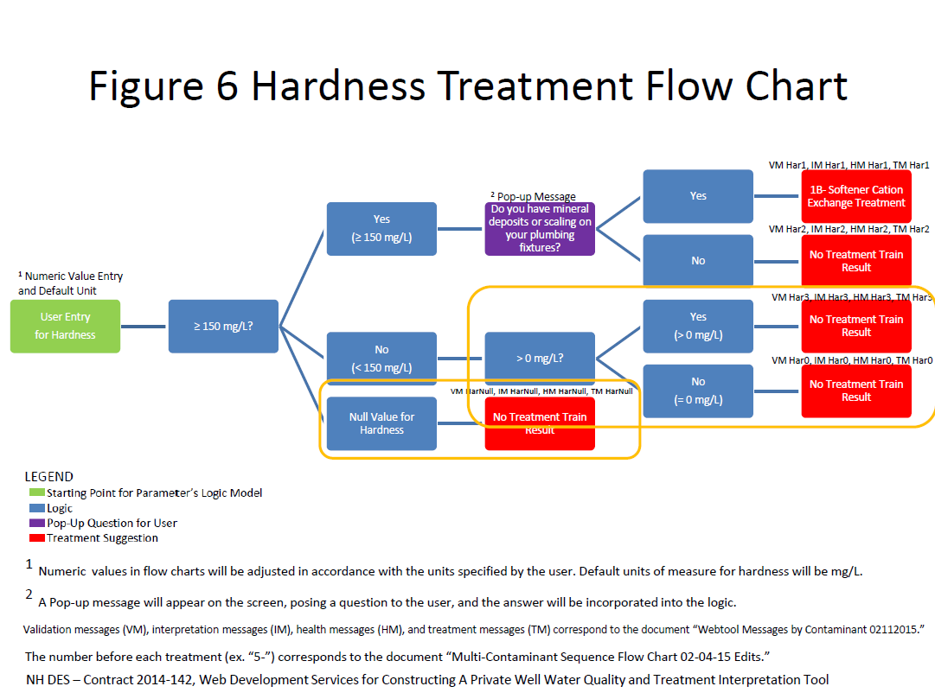

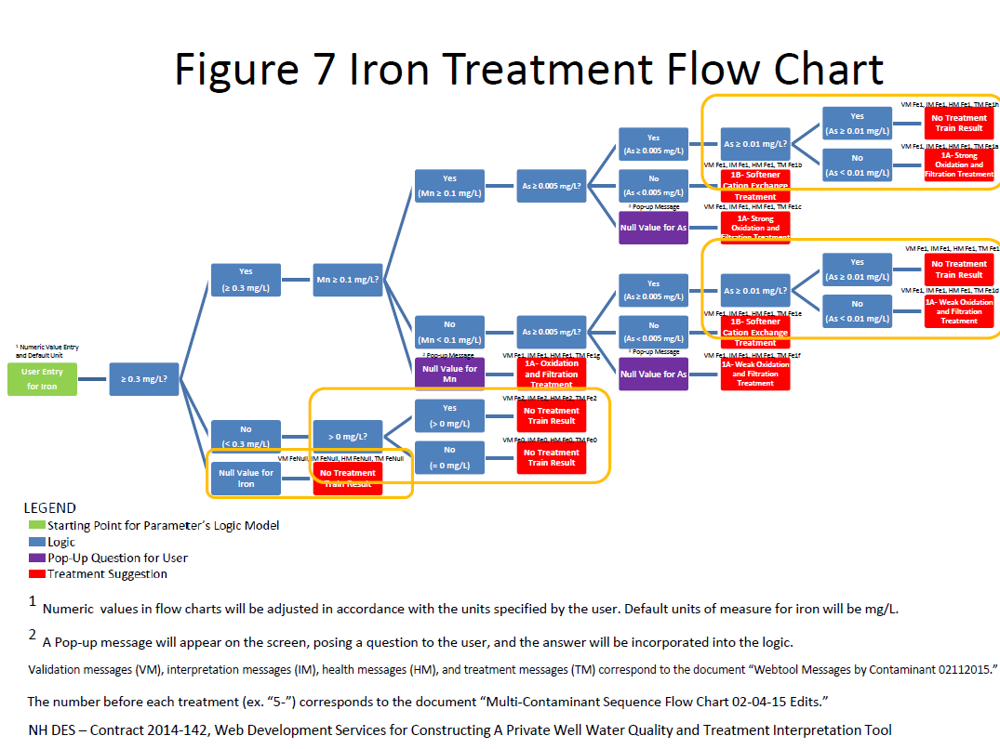

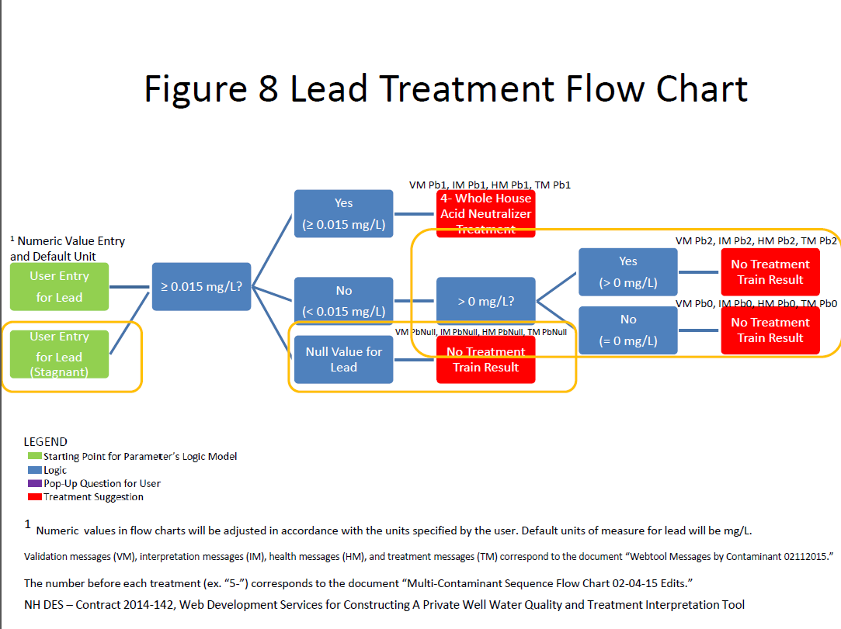

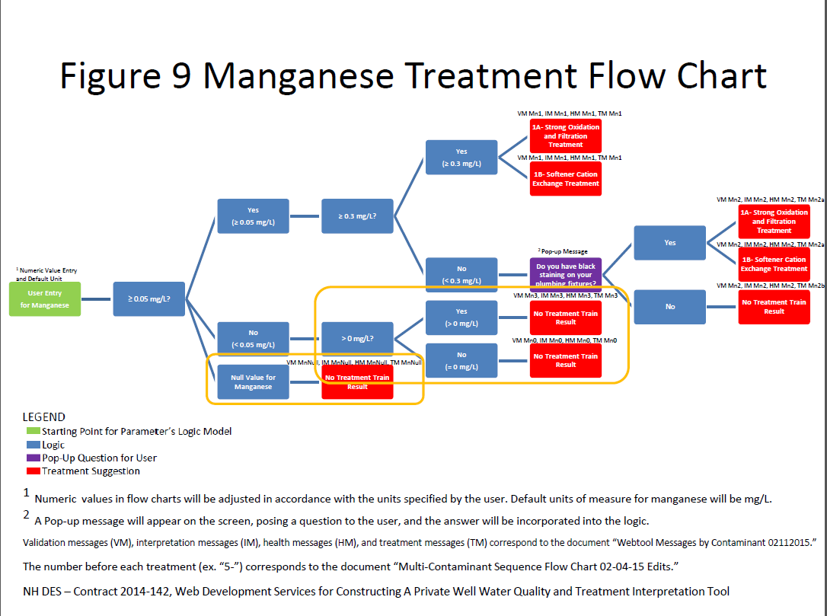

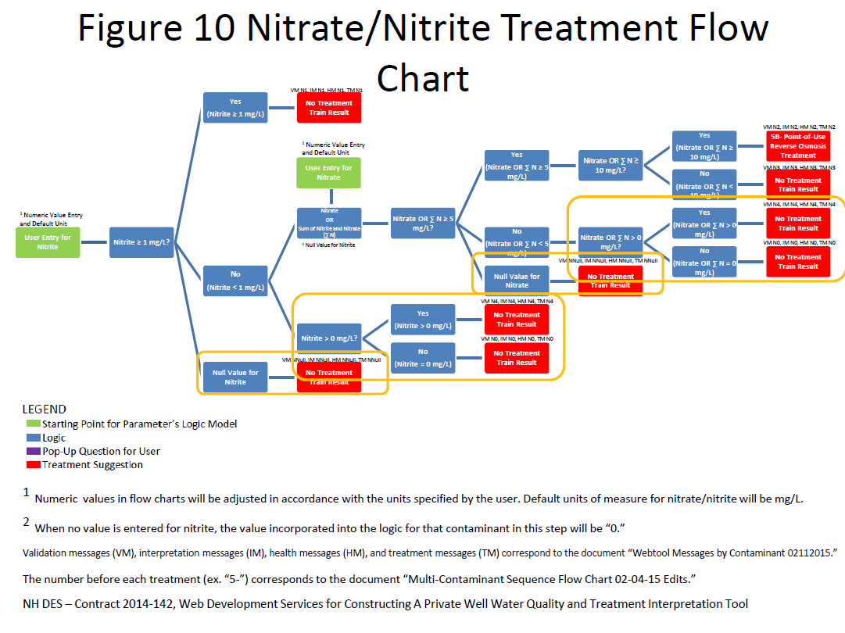

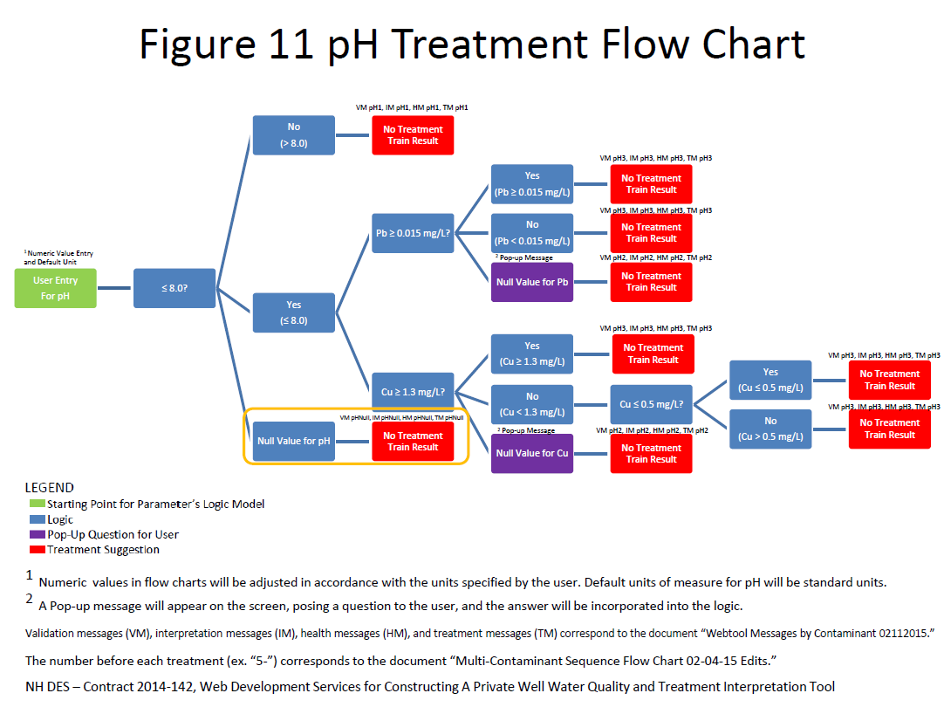

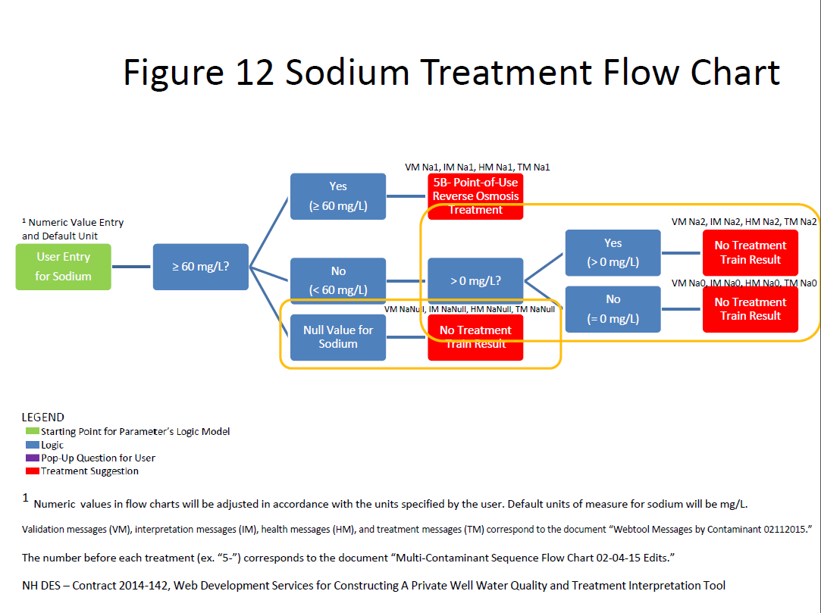

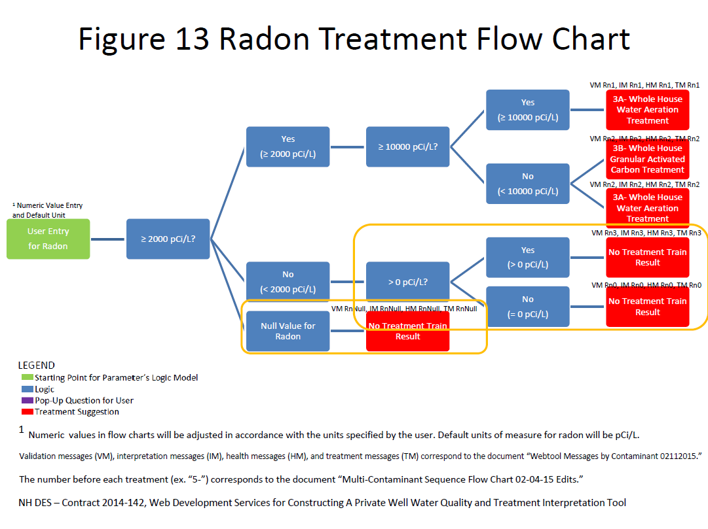

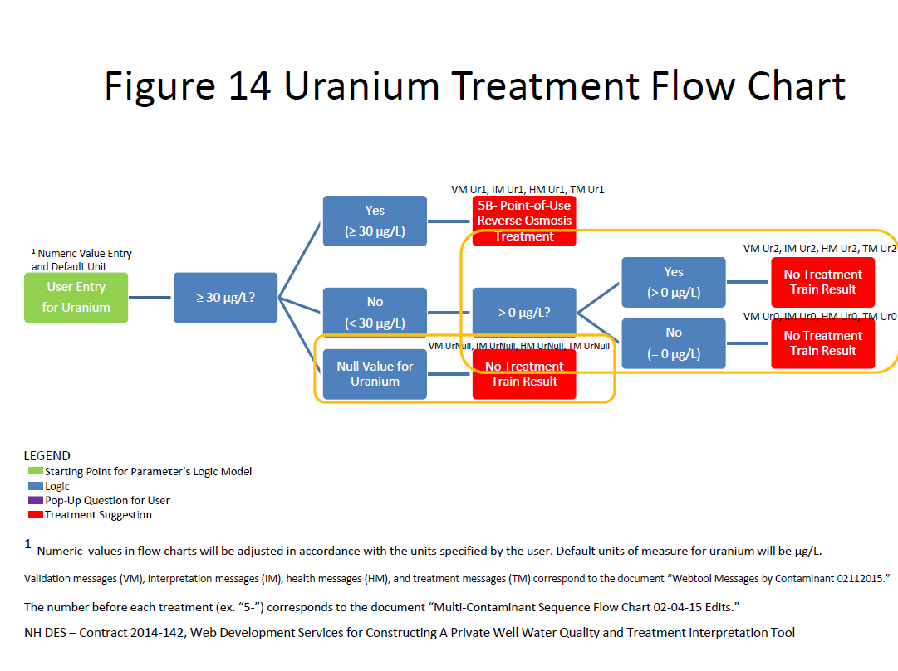

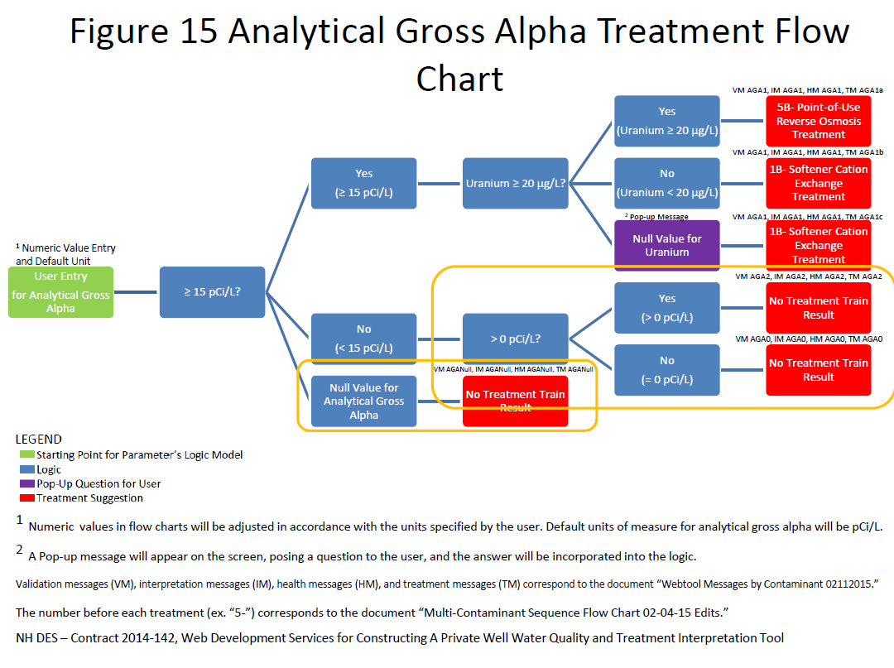

1.
2. Depending on resource availability, there may be a need to establish a pace for partner adoptions.
3. As partners adopt the tool, we will develop these metrics and TBD will be replaced.
4. Note: Coding time may increase with more configurable elements in the widget.
5. After a period of use in production, the use metric will inform this response.
6. EPA's Cross-Media Electronic Reporting Regulation (CROMERR) sets performance-based, technology-neutral security and performance standards for systems that States, Territories, Tribes, and local governments use to receive electronic reports or other documents from facilities they regulate under EPA-authorized programs. CROMERR establishes standards for information systems that receive reports and other documents electronically. The standards are designed to provide electronic submittals with the same level of legal dependability as the corresponding paper submittals.
7. The CDX Helpdesk provides helpdesk support for the E-Enterprise Portal.